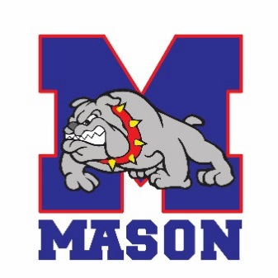
Inspire ~ Empower ~ Succeed
__________________________________________________________

REGISTRATION PROCESS
- Submit completed application and documentation via:
E-mail: Pfostl@MasonK12.net , Fax: (517) 244-6412 or in person.
- Your application will be reviewed for approval by an administrator.
- An appointment will be scheduled with a counselor.
- All applications submitted after October 1st must meet with an administrator prior to final approval.

- Resident
- Non-Resident Application - Must complete additional application. You will need to request this application. Must include ALL requested documentation. You must re-apply each year.

Documents in this packet that need to be completed:
- Student Registration Form

- Home Language Survey

- Records Request

- Residency Verification Affidavit – (See form for details, will need additional documentation and completed form.)

- Concussion Awareness Form

- Student Handbook Verification/Media Consent Form

- Special Education Temporary Placement Services Form (MUST provide most recent IEP/504, if applicable.)

- Free and Reduced Lunch Form
Additional Required Documents:
- Original Birth Certificate (We will make a copy and return the original.)

- Record of Immunizations (Include actual date of Chicken Pox, if applicable.)

- High School Transcript – It must list classes taken at previous school. Include check-out grades, if leaving previous school prior to the end of semester/trimester/term.

- Proof of Guardianship/Custody, if not parent

- Intake with Administration (Required after October 1)
A separate intake meeting must be scheduled with the administration for all students enrolling after the start of the school year. We will make every attempt to schedule this meeting in conjunction, with the counseling office; however, an additional meeting date may be necessary prior to enrollment. An appointment will not be scheduled until ALL information is received from check list.

**Any misrepresentations, false statements or acts of an untruthful nature related to any information provided or completed in conjunction this packet or the enrollment process could result in exclusion from Mason Public Schools.
Parent or Guardian Signature: _____________________________________________________________________

